Genealogy & The Social Sphere Referral Program
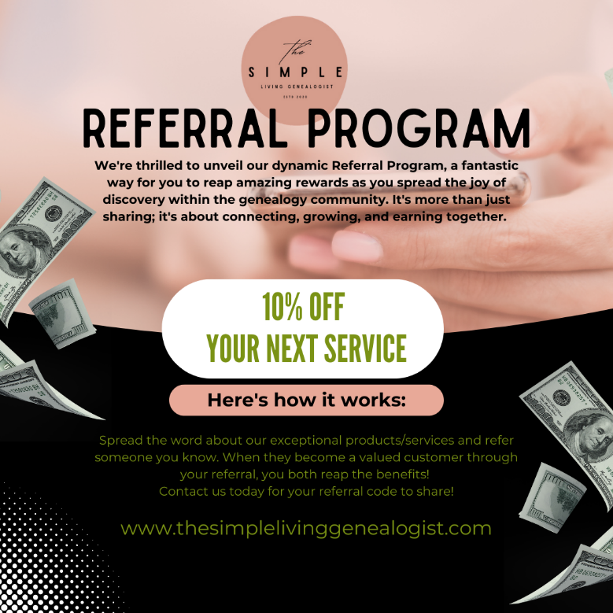
We’re thrilled to unveil our dynamic Referral Introducing The Genealogy & The Social Sphere Referral Program – our heartfelt way of expressing gratitude when you spread the word about The Simple Living Genealogist’s Social Media Services. It’s a win-win: for every successful referral you make, we’re delighted to offer you a 10% discount on your next month’s services. Here’s how it works:
- Spread the Word: Sharing your experience with The Simple Living Genealogist’s services within your network.
- Successful Sign-Up: When you referral signs up and commits to at least one month of our services or opts for personalized content creation, you’re on your way to earning your reward.
- Ear Your Discount: After your referred client has availed of our service, a 10% discount will be credited to you for your next month’s services.
Please note, this discount is a token of our appreciation for bringing new members into out community. It is non-transferable and cannot be converted into cash. The discount is exclusively for new referrals – each new connection brings a new opportunity!
Thank you for being a valued member of The Simple Living Genealogist community and helping us grow. Your support allows us to continue providing top-notch social media services tailored for the genealogist community. Let’s make our genealogy community thrive together in the social sphere!
If you have any questions or would like a personalize referral code, please reach out to me through social media or email me directly at Jonmarie.pearson@thesimplelivinggenealogist.com.

